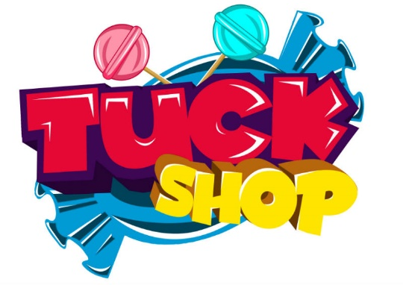

12th September 2023

Dear Parents and Carers,
Our School Council has exciting news – they are ready to start running a Tuck Shop.
The tuck shop will be run by Year 6 School Councillors and a TA. This will start week beginning Monday 18th September 2023. To begin with, and so we can see if the shop is sustainable, we will only be running it for two days a week for particular year groups:
- Tuesday – Year 3 and 4 only
- Thursday – Year 5 and 6 only
We are intending to sell snacks like raisins, cereal bars and oatie biscuits to begin with to enable the children to buy a light snack between breakfast and lunch. Prices will range from 10p to 35p. After the shop has been running for a few weeks, we may be able to adjust these prices if we are able to keep stocking the shop with funds raised.
Can we kindly ask that children bring no more than 50p/60p and that they bring in loose change only, NO NOTES please, this will make it far easier for the children to manage.
The School Council are very excited about this and looking forward to getting it up and running next week.

Kind regards

Miss Bushell
PSHE Lead

